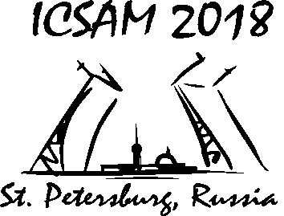

REGISTRACION FORM

13th International Conference on Superplasticity in Advanced Materials
ICSAM 2018

August 19-22, 2018

Saint Petersburg, Russia
Family name |  |  | First name
Phone / Fax: |  |  | e-mail:
Arrival date: |  |  | Departure date:

Please, tick/ check the room type you require:

Room type | Special rates
 | Single | Double
Standard room | 2600.00 rub | 2800.00 rub

Migration fee for foreigners or stateless citizens, staying at the hotel is 200 RUR per person.

